1. Abstract

Tic-tac-toe (American English), noughts and crosses (Commonwealth English), or Xs and Os (Canadian or Irish English) is a paper-and-pencil game for two players who take turns marking the spaces in a three-by-three grid with X or O. The player who succeeds in placing three of their marks in a horizontal, vertical, or diagonal row is the winner. It is a solved game, with a forced draw assuming best play from both players.

2. Introduction
Tic-tac-toe is played on a three-by-three grid by two players, who alternately place the marks X and O in one of the nine spaces in the grid.
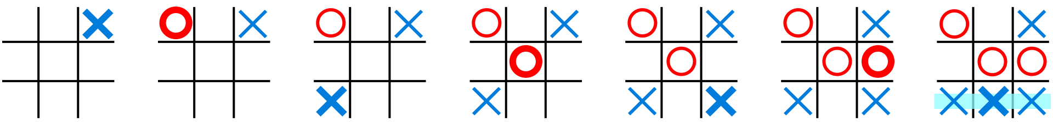
In the following example, the first player (X) wins the game in seven steps:

Fig 1.Tic Tac Toe Structure
There is no universally-agreed rule as to who plays first, but in this article the convention that X plays first is used.
Players soon discover that the best play from both parties leads to a draw. Hence, tic-tac-toe is often played by young children who may not have discovered the optimal strategy. Because of the simplicity of tic-tac-toe, it is often used as a pedagogical tool for teaching the concepts of good sportsmanship and the branch of artificial intelligence that deals with the searching of game trees.
It is one of the most popular two-player pen-and-paper games. This two-player pen-and-paper game has extremely ancient roots and is popular in many countries. The game’s rules are straightforward and well-known. Two players, X and O, will play this game by alternately marking the squares in a 3X3 grid. The game is won by the person who successfully arranges three of their marks in a row that is either horizontal, vertical, or diagonal. Only one symbol may be placed by each player at every turn, after which the turn is passed to the other player.

Game Approach And Specific Aspects
Tic-tac-toe is an ideal educational game for teaching youngsters the development of logic and sportsmanship because of its simplicity.
A n x n version of the traditional 3 x 3 game of tic-tac-toe may be created in which the two players alternately put their symbols on a n × n board to line up d of their symbols in a row that is either vertical, horizontal, or diagonal. In this blog, we’ll use Java programming to create a game Tic Tac Toe console version. The fundamental concept is to manage the game board using a two-dimensional array or board. This array’s cells contain values that specify whether they are empty or have an X or an O.
Consider a 3 x 3 board so the player board will look like the image below.
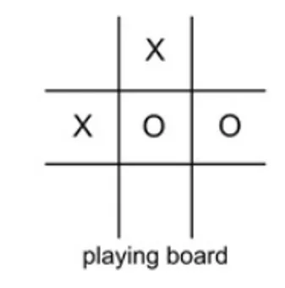

Fig 2.Tic Tac Toe board
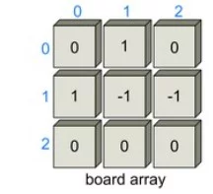
And the board array will look something like the below image.

Fig 3.Two-Dimensional board array
The center row of the 3 x 3 matrix board has the cells board[1][0], board[1][1], and board[1][2], where the first number represents the row number and the second number represents the column number of the board.
Specific aspects to consider about the game in Java
- The program outputs a 3×3 board with dashes, which stand for vacant spaces.
- The board is again printed with the x or o in the appropriate position after each turn by asking either player 1 or player 2 to input a row and col index representing where they wish to place their x and o.
- Our application alerts the player and asks them to enter another row and col if the place they entered is “off the board” or already contains an x or o.
- The program prints out the final board and notifies players 1 or 2 that they have won after they obtain 3 symbols in a row, column, or diagonal.
- Wins: Each player attempts to arrange three symbols in three adjacent cells that are either horizontally, vertically, or diagonally spaced. The winner is the one who accomplishes this alignment first. The second player attempts to obstruct Player 1’s alignment by inserting his symbols between Player 1’s symbols.
- Lose: You lose if your rival achieves the necessary symbol alignment faster.
- Draw: If none of the players achieves the necessary alignment, all nine grip cells are marked.. A draw or tie is the outcome. In this scenario, none of the players receives a point. Throughout the game, this circumstance occurs frequently and is quite entertaining.

General Implementation Order
- Dashes should be placed on a Tic Tac Toe board.
- Create a function that squares up the board.
- The player’s turn and the symbol they are using should be noted.
- Ask for a row and a col repeatedly until they are appropriate.
- Set the appropriate symbol in the relevant place on the board.
- Make a function that determines who won the game.
- Test to see if there was a tie in the game.
- To keep the game alive, use a loop.


Fig 4.Tic Tac Toe Implementation

- Algorithm
Step I : Start
Step II : To simulate the tic tac toe board, make a 3×3 array and fill it with dashes
This line of code is used to create a 3×3 character array. Each point on the board is iterated through using a nested for loop. We may put board[i][j] equal to a dash within both for loops.
Step III: Make a function that prints the board as a 3×3 square after the board is drawn
For the function to be able to print the board 2D array, we must supply it. Since the function only prints the board, we don’t need to return anything.We need to print out each place on our board inside of our function.
Step IV: Make a function that prints the board as a 3×3 square after the board is drawn
In our game, we need a means to keep track of which player is taking turns. We will use a boolean variable named player1 that is true when player 1 is doing the turn and false when player 2 is.
Step V: Ask for a row and a col repeatedly until they are appropriate
Use the Scanner to obtain the user’s input and store it in a variable named row after printing a message asking for a row; do the same for a variable called col. The row and col are invalid if the user enters them in a position that is not on the board. To determine whether the row and col are not larger than 2 and not less than 0, use a conditional. The row and col are invalid if the user enters them in a cell that already has an x or an o on it. Check to see if the board location at row and col already has an x or o by using a conditional. We want to prompt the user to re-enter a row and col if they input a row and col that is outside of bounds or that already has an x or o on it. For this, we will use the while loop which will work great! And it will break out of the loop once the player has entered a valid row and col.
Step VI: Set the appropriate symbol in the relevant place on the board
We are clear that we have an appropriate row and col outside of the while loop.By doing board[row][col], we may obtain the desired location on the board.Now that we have put the player’s character in the variable c, we can set this position to equal that value.
Step VII: Make a function that determines who won the game
A player in the game of tic tac toe wins if they line up three of their symbols in a row, column, or diagonal.Start off with rows. To iterate through each row we may use a for loop.We may use a conditional within the for loop to determine if board[i][0] equals board[i][1] and whether board[i][1] equals board[i][2]. Remember that in order to prevent winning if there are three consecutive empty places, we must additionally verify that board[i][0] does not equal a dash. We can return the value of board[i][0] if everything is true.Similar procedures may be used for columns.On the board, there are two diagonals that need to be examined. Similar to the if statements we used for rows and columns, we can use two if statements to verify the two diagonals.When our function is complete, it indicates that no one has won. Then let’s return space in this case.
Step VIII: Test to see if there was a tie in the game
A player in the game of tic tac toe wins if they line up three of their symbols in a row, column, or diagonal.Start off with rows. To iterate through each row we may use a for loop.We may use a conditional within the for loop to determine if board[i][0] equals board[i][1] and whether board[i][1] equals board[i][2]. Remember that in order to prevent winning if there are three consecutive empty places, we must additionally verify that board[i][0] does not equal a dash. We can return the value of board[i][0] if everything is true.Similar procedures may be used for columns.On the board, there are two diagonals that need to be examined. Similar to the if statements we used for rows and columns, we can use two if statements to verify the two diagonals.When our function is complete, it indicates that no one has won. Then let’s return space in this case.
Step IX: To keep the game alive, use a loop
We may make a boolean named gameEnded and set it to false at the beginning. We may set gameEnded to true inside the if statement, which is where we determine if a player has won or whether it is a tie.In order for the program to continue requesting a player to enter a row and a column until a winner or a tie is determined, we may create a while loop with the condition simply being gameEnded.We can draw the board one last time once the while loop is finished so that both players can view the board’s final configuration.
Step X: Stop

- Program
HTML Code:-
<!DOCTYPE html>
<html lang="en">
<head>
<meta charset="UTF-8">
<meta name="viewport" content="width=device-width, initial-scale=1.0">
<meta http-equiv="X-UA-Compatible" content="ie=edge">
<link rel="stylesheet" href="styles.css">
<script src="script.js" defer></script>
<title>Document</title>
</head>
<body>
<div class="board" id="board">
<div class="cell" data-cell></div>
<div class="cell" data-cell></div>
<div class="cell" data-cell></div>
<div class="cell" data-cell></div>
<div class="cell" data-cell></div>
<div class="cell" data-cell></div>
<div class="cell" data-cell></div>
<div class="cell" data-cell></div>
<div class="cell" data-cell></div>
</div>
<div class="winning-message" id="winningMessage">
<div data-winning-message-text></div>
<button id="restartButton">Restart</button>
</div>
</body>
</html>

JavaScript Code:-
const X_CLASS = 'x'
const CIRCLE_CLASS = 'circle'
const WINNING_COMBINATIONS = [
[0, 1, 2],
[3, 4, 5],
[6, 7, 8],
[0, 3, 6],
[1, 4, 7],
[2, 5, 8],
[0, 4, 8],
[2, 4, 6]
]
const cellElements = document.querySelectorAll('[data-cell]')
const board = document.getElementById('board')
const winningMessageElement = document.getElementById('winningMessage')
const restartButton = document.getElementById('restartButton')
const winningMessageTextElement = document.querySelector('[data-winning-message-text]')
let circleTurn

startGame()

restartButton.addEventListener('click', startGame)

function startGame() {
circleTurn = false
cellElements.forEach(cell => {
cell.classList.remove(X_CLASS)
cell.classList.remove(CIRCLE_CLASS)
cell.removeEventListener('click', handleClick)
cell.addEventListener('click', handleClick, { once: true })
})
setBoardHoverClass()
winningMessageElement.classList.remove('show')
}

function handleClick(e) {
const cell = e.target
const currentClass = circleTurn ? CIRCLE_CLASS : X_CLASS
placeMark(cell, currentClass)
if (checkWin(currentClass)) {
endGame(false)
} else if (isDraw()) {
endGame(true)
} else {
swapTurns()
setBoardHoverClass()
}
}

function endGame(draw) {
if (draw) {
winningMessageTextElement.innerText = 'Draw!'
} else {
winningMessageTextElement.innerText = `${circleTurn ? "Secound Player" : "First Player"} Wins!`
}
winningMessageElement.classList.add('show')
}

function isDraw() {
return [...cellElements].every(cell => {
return cell.classList.contains(X_CLASS) || cell.classList.contains(CIRCLE_CLASS)
})
}

function placeMark(cell, currentClass) {
cell.classList.add(currentClass)
}

function swapTurns() {
circleTurn = !circleTurn
}

function setBoardHoverClass() {
board.classList.remove(X_CLASS)
board.classList.remove(CIRCLE_CLASS)
if (circleTurn) {
board.classList.add(CIRCLE_CLASS)
} else {
board.classList.add(X_CLASS)
}
}

function checkWin(currentClass) {
return WINNING_COMBINATIONS.some(combination => {
return combination.every(index => {
return cellElements[index].classList.contains(currentClass)
})
})
}

CSS Code:
*, *::after, *::before {
box-sizing: border-box;
}

:root {
--cell-size: 100px;
--mark-size: calc(var(--cell-size) * .9);
}

body {
margin: 0;
}

.board {
width: 100vw;
height: 100vh;
display: grid;
justify-content: center;
align-content: center;
justify-items: center;
align-items: center;
grid-template-columns: repeat(3, auto)
}

.cell {
width: var(--cell-size);
height: var(--cell-size);
border: 1px solid black;
display: flex;
justify-content: center;
align-items: center;
position: relative;
cursor: pointer;
}

.cell:first-child,
.cell:nth-child(2),
.cell:nth-child(3) {
border-top: none;
}

.cell:nth-child(3n + 1) {
border-left: none;
}

.cell:nth-child(3n + 3) {
border-right: none;
}

.cell:last-child,
.cell:nth-child(8),
.cell:nth-child(7) {
border-bottom: none;
}

.cell.x,
.cell.circle {
cursor: not-allowed;
}

.cell.x::before,
.cell.x::after,
.cell.circle::before {
background-color: black;
}

.board.x .cell:not(.x):not(.circle):hover::before,
.board.x .cell:not(.x):not(.circle):hover::after,
.board.circle .cell:not(.x):not(.circle):hover::before {
background-color: lightgrey;
}

.cell.x::before,
.cell.x::after,
.board.x .cell:not(.x):not(.circle):hover::before,
.board.x .cell:not(.x):not(.circle):hover::after {
content: '';
position: absolute;
width: calc(var(--mark-size) * .15);
height: var(--mark-size);
}

.cell.x::before,
.board.x .cell:not(.x):not(.circle):hover::before {
transform: rotate(45deg);
}

.cell.x::after,
.board.x .cell:not(.x):not(.circle):hover::after {
transform: rotate(-45deg);
}

.cell.circle::before,
.cell.circle::after,
.board.circle .cell:not(.x):not(.circle):hover::before,
.board.circle .cell:not(.x):not(.circle):hover::after {
content: '';
position: absolute;
border-radius: 50%;
}

.cell.circle::before,
.board.circle .cell:not(.x):not(.circle):hover::before {
width: var(--mark-size);
height: var(--mark-size);
}

.cell.circle::after,
.board.circle .cell:not(.x):not(.circle):hover::after {
width: calc(var(--mark-size) * .7);
height: calc(var(--mark-size) * .7);
background-color: white;
}

.winning-message {
display: none;
position: fixed;
top: 0;
left: 0;
right: 0;
bottom: 0;
background-color: rgba(0, 0, 0, .9);
justify-content: center;
align-items: center;
color: white;
font-size: 5rem;
flex-direction: column;
}

.winning-message button {
font-size: 3rem;
background-color: white;
border: 1px solid black;
padding: .25em .5em;
cursor: pointer;
}

.winning-message button:hover {
background-color: black;
color: white;
border-color: white;
}

.winning-message.show {
display: flex;
}

- Output Of Micro-Project:

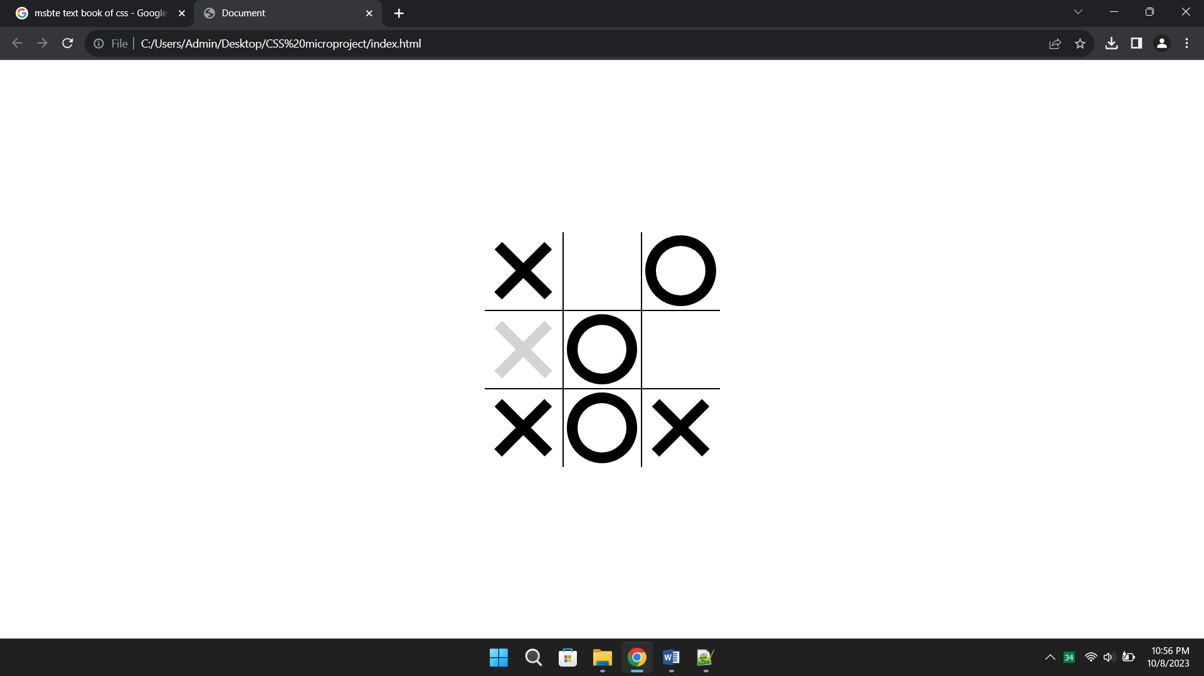
Fig. 5 Game Board

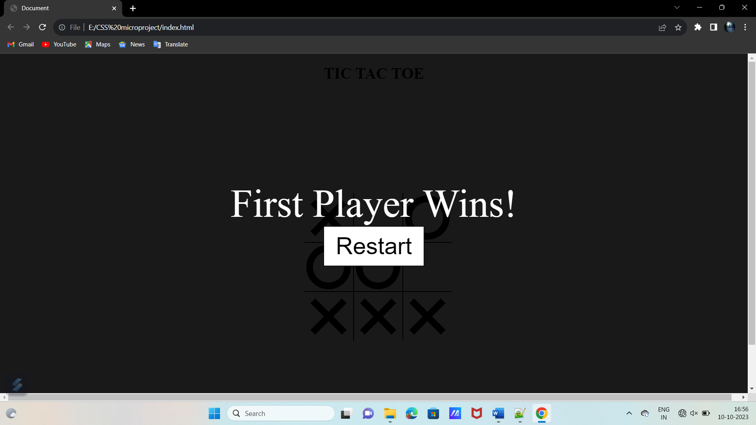Fig. 6 Winning Result

- Conclusion
In this Microproject, we learned how to implement the fundamental tic-tac-toe game in Javascript. We have used the two-dimensional array, boolean variables, loops, conditional statements and many more concepts of Javascript as well as uses html tags.
Learning to code can give your child the foundational skills for future success. Basic programming knowledge can change the way kids interact with the technologies they use daily. It’s a basic literacy–one we can’t afford to overlook. We learnt so many thing and gained a lot of knowledge about development field.

- References
We Referred Some Website :
- https://www.codingal.com/coding-for-kids/blog/tic-tac-toe-game-in-javasript/
- https://lucidmanager.org/data-science/tic-tac-toe-war-games/
- https://en.wikipedia.org/wiki/Tic-tac-toe

We Referred Some Book :

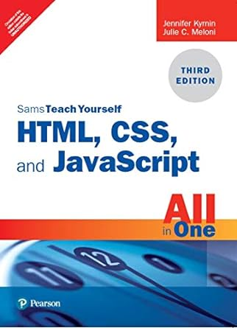
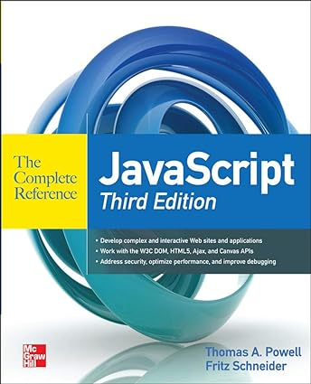

Referred Some You-Tube Video :
- https://www.youtube.com/watch?v=M6QuAMC2xXkhttps://www.youtube.com/watch?v=M6QuAMC2xXk
- https://www.youtube.com/watch?v=otHIBvufOrc&list=RDCMUCvT21bzLRHrnAc-F1SRqRSw&index=3

